Food Truck Ordering
1 December 2025
Jaden Wattley
Robert Wickliffe
Sean Staley

Table of Contents
Title pg. 1
Table of contents pg. 2
Brief overview/description of the project pg. 3-4
Requirements pg. 4-5
Initial Implementation Milestones pg. 6
Methodology used for project pg. 7
Need analysis pg. 8
Software Design pg. 9-10
Risk Analysis pg. 11
Potential ethical issues pg. 12
Screenshot of your codes pg. 13
Test Plan pg. 14
Team Assignments and Responsibilities pg. 15
Ethical Guidance pg. 16
References pg. 17

Brief overview of Food Truck Ordering
The Food Truck Ordering App is a comprehensive web application designed to streamline the ordering process for a food truck business. The system provides a dual interface solution: a customer-facing order placement portal and a staff-facing order management dashboard.
Project Goals
The primary goal of this project is to digitize and optimize the food truck ordering workflow, eliminating manual order-taking processes and providing real-time order tracking capabilities.
The system aims to:
- Enable customers to place orders quickly and efficiently through an intuitive web interface
- Provide food truck staff with a centralized dashboard to manage incoming orders
- Generate estimated preparation times based on current order queue
- Track order status throughout the preparation lifecycle
The application is built using modern web technologies:
- Frontend: React 18 with Vite for fast development and optimized builds
- Backend: Node.js with Express framework for RESTful API services
- Initial Prototyping: C++ for business logic validation
- Styling: Custom CSS with responsive design principles
Core Functionality
The system handles the complete order lifecycle from placement to completion:
1. Order Placement Customers: select their meal preferences (main item, sides, drinks) and provide their name
2. Order Confirmation System: generates unique order numbers and provides estimated preparation times
3. Order Management: Staff can view all orders, filter by status, update order progress, and modify order details
The application serves as a proof-of-concept for modernizing small business operations through accessible web technologies, demonstrating full-stack development capabilities and software engineering principles.

Requirements
The system should provide an order placement capability that allows customers to select from a defined set of menu items. Main items include burgers and hot dogs. Customers may also choose a side option of fries, salad, or no side, along with a drink selection of soda, or water. To ensure proper identification, the system will require the customer’s name before submission. Each order will be assigned a unique order number beginning at 100001, and upon placement, the system will display a confirmation message containing the selected items and an estimated preparation time. Validation will be enforced so that required fields such as name, food choice, and drink are completed before an order can be submitted.
For order management, the system should provide a dashboard view that displays all active orders. Staff will be able to filter orders by status, including All, Pending, Preparing, Ready, and Completed. Each order’s status can be updated through a dropdown selection, and staff will have the ability to edit order details or delete orders, with a confirmation prompt to prevent accidental removal. The dashboard will also display order statistics, including total orders and counts for pending, preparing, and ready orders, giving staff a clear overview of operational flow.
The system should include a time estimation mechanism that calculates preparation time based on the type of food ordered. Burgers will have a base preparation time of eight minutes, while hot dogs will have a base time of five minutes. To account for workload, the system will add one minute per active order in the queue. This estimated preparation time will be displayed to customers now of order placement, ensuring transparency and setting expectations.
From a non-functional perspective, the system shall meet performance requirements by responding to user actions within two seconds, loading the front end within three seconds on standard connections, and ensuring API endpoints process requests within 500 milliseconds. Usability will be prioritized through an intuitive interface that requires no training for basic operations, responsive design across desktop, tablet, and mobile devices, and clear, actionable error messages. Reliability will be achieved by handling concurrent orders without data loss, providing fallback mechanisms when APIs are unavailable, and maintaining data consistency across operations.

Methodology used for the project
For this project, an Iterative and Incremental Development methodology was adopted, blending Agile principles with the practical constraints of an academic environment. The team began with a prototyping‑first strategy, creating early C++ prototypes to validate core business logic and static HTML/CSS mockups to explore the user interface before committing full implementation. This approach allowed rapid feedback and refinement of both functionality and design. Development then transitioned into a component‑based model, leveraging Reacts modular architecture to enforce separation of concerns and maximize reusability across the system.
On the backend, an API‑first design philosophy was followed, with RESTful endpoints defined and documented upfront to establish clear contracts before frontend integration. Collaboration was supported through version control practices, using Git and GitHub with feature branches and peer code reviews to ensure quality and maintain consistency across contributions.
Finally, a structured testing strategy was employed, beginning with unit tests for individual components, extending to integration tests for API interactions, and culminating in user acceptance testing to validate the system against real‑world expectations. Together, these practices ensured that the project evolved incrementally, maintained alignment with Agile values, and delivered a reliable, maintainable solution within the academic timeline.

Need analysis
The current system of manual order taking presents several challenges, including illegible handwriting, frequent errors, and a lack of tracking. These issues negatively impact the customer experience, leading to long wait times, no visibility into order status, and unclear expectations about waiting durations. From a business perspective, inefficiencies arise due to difficulties in managing queues, the absence of analytics, and limited scalability. Additionally, communication gaps contribute to miscommunication, problems with order modifications, and a lack of prioritization.
The target users for the proposed solution include both customers and staff. Primary users are members of the public with basic web skills who need a quick and simple way to place orders, access menu information, receive confirmation, and view estimated wait times. Secondary users are food truck employees who require a centralized dashboard with real-time updates, queue management tools, and editing capabilities to streamline operations.
Key features of the solution, based on analysis, include a simplified ordering process with built-in validation, dynamic time management with estimation and status tracking, staff efficiency tools such as filters, one-click updates, and statistics, as well as accessibility features like responsive design, clear hierarchy, and color-coding. These features collectively deliver strong business value by reducing order errors, speeding up service, improving customer satisfaction, enabling data-driven insights, and supporting scalability.

Software Design
The proposed system architecture follows a client-server model with three distinct layers. The client layer consists of a React frontend running on port 3000, while the server layer is built with Node.js and Express on port 5000, providing six API endpoints. The data layer relies on in-memory storage to handle application data. The architecture is influenced by MVC principles, incorporates RESTful API design, and leverages React’s component-based structure.
On the frontend, the design emphasizes a clear component hierarchy, including App.jsx, FoodTruckForm, OrderManagement, and their respective child components. State management is carefully defined with detailed state objects for each component, ensuring smooth workflow for both customers and staff. User interaction flows are mapped step by step, while styling is handled through CSS variables and responsive breakpoints to maintain consistency across devices.
The backend design works like a well-organized system that keeps everything running smoothly behind the scenes. It has a setup that makes sure requests from customers are handled properly and responses are sent back quickly. To keep service accurate, it includes a feature that estimates waiting times so customers know when their orders will be ready. The process of creating an order follows a clear, step-by-step path to avoid confusion. If something goes wrong, the system checks for mistakes and gives clear messages so problems can be fixed easily, ensuring everything stays reliable.
Data models are defined for both orders and menus. The order model includes a complete schema with field types and descriptions, while the menu model structures items such as burgers, hot dogs, sides, and drinks. Example data is provided in JSON format to illustrate how orders are represented.
The API endpoints are fully documented, covering request and response formats, status codes, and for example payloads for all six routes. User interface design follows principles of simplicity, clarity, feedback, consistency, and accessibility. A defined color scheme with hex codes supports visual hierarchy, while status color coding enhances usability. Layouts are designed for forms and dashboards, supported by responsive strategies and modal designs to ensure a seamless experience across devices.

Risk Analysis
Some of the risks that could arise are: Security, privacy, and operational risk. These will be liabilities that could cause massive problems for the company that would impact performance.
Security risk that can cause problems is data leaks if there happens to be weak security that would cause it to become comprises, this would be a big risk cause legal issues that would hurt the company.
The privacy risk would be the over collecting data of the site's users. This is a big problem because if too much info is collected, that could lead to invasion of privacy and lead to the problem above.
And finally, operational risk, this would become a problem when the app is under lots of stress, some issues can happen during lunch rushes and other times when people will be using the app a lot more and would cause the server to lag or to crash completely, this will lead to orders being dropped and consumers becoming angry that their order was never received.

Potential Ethical Issues
Some of the potential ethical issues that may arise are Data privacy and collection. This first issues addresses how users will react to having to input payment details into the app to finish the order. A lot of people may not trust that the app will have a decent security in place to contain the data of cards that were inputted. Some may feel that their personal data on the app may be sold to third parties without their knowledge. This can really hurt the app in launching if sensitive data will not be handled to the consumers liking and causes for data concern. The way this will be handled is by not having the app save user data and having them reenter every time they use the app. This may be tedious, but it is a good way to minimize data leaks and cause for concerns because no data is being saved inside any servers or services.
Another Ethical issue that was considered is accessibility for people with disabilities. This would be a problem if the app was designed for people without disabilities. Cause it would discriminate against them from using the service that is not accommodating to people with disabilities. The way this would be implemented is to add a screen reader to the app to help people with visual impairments. This will allow more users to use the app to order their food form the truck.
The last Ethical issue that is a major topic would be reliance on tech. The issue is if the said company uses the app only and doesn’t have a physical way to order their food. this can lead to them having limited customers because there are not fortunate enough to own a device that can access the internet. This would be a problem if the company that would only use the app to place orders

Screenshots of code
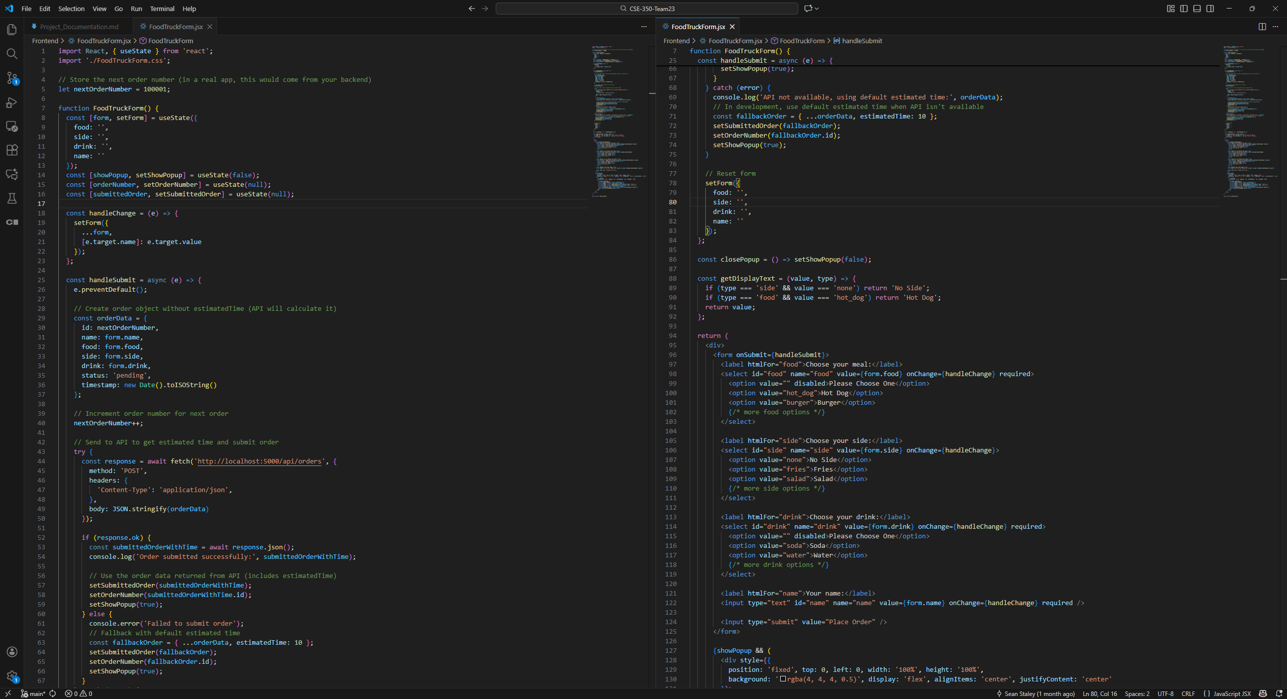
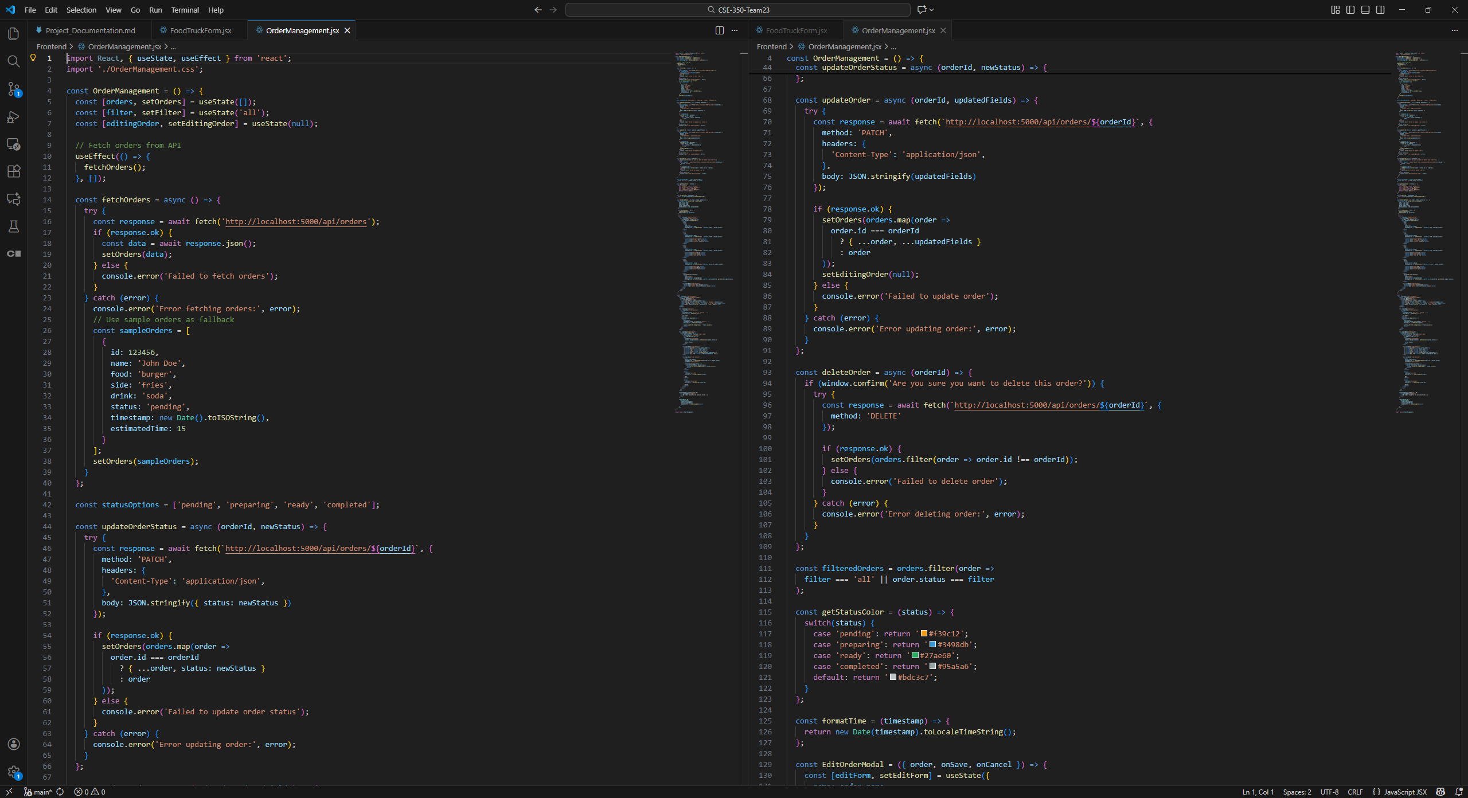

Test plan
The purpose of our test plan is to validate the functionality, performance, usability, and reliability of our Food Truck Ordering Application. The application allows customers to browse the food truck’s menu, place orders, make payments, and track their order status. Our testing would be handled through using manual and automated testing.

For our manual testing purposes, checks would be performed to check if ui/ux features function properly, testing for application performance across different platforms, and exploratory testing through application usage for more fringe case scenarios. Load testing and test for security vulnerabilities in the application would additionally be handled manually.
For our automated testing purposes, we would use smoke teat for our initial deployment and subsequent deployments to ensure that the critical functionalities of our application are performing correctly. Additionally, a regression suite would be used to test the core functionality of our applicationl

Team Assignments and Responsibilities
Sean Staley - Project Manager, Frontend Developer, Server-Side Developer
Sean worked on setting up the GitHub repository, Discord server, and Jira to organize collaboration and communication. He also developed the front end and configured the server so that customer orders could be submitted to the backend and then passed along to the staff-facing frontend, ensuring both sides of the system connected and functioned smoothly.
Jaden Wattley - Backend Engineer / Product Engineer
Jaden worked on getting the backend of the code working so that the app could function as intended. Without the backend code, the entire app would not work at all or be usable before the deadline. He made the backend code very easy to read to allow easier read of the code so it code be connected to front easily. Having comments that show what that section of the code does.
Robert Wickliffe - Full Stack Developer
Connor Raque - None

Ethical Guidance
One of the primary ethical guidelines that should be focused on when creating a food truck ordering application is the handling of user data. It it important that this data is stored securely and different data is handled according to their practices and guidelines.
One of the main areas of focus for us is the handling of user payment information. This information should be stored securely and some information should he encrypted using current standards. It is recommended to use a third-party payment processor, such as stripe, to handle payment between our service and users. The usage of this ensures that we can meet current standards an guidelines and ensures a stable payment platform for our clients and users.
Our next area is user data such as personal information, such as names, and account information such as passwords. User’s personal information such as names, emails, and phone numbers, should be kept private from others or only displayed in designated areas in our application. User passwords should be hashed to be stored securely.

References
Project files zip https://github.com/SeanStaley21/CSE-350-Team23/blob/main/Team23Submission.zip

